Branching AI Chat Platform – Comprehensive Product Analysis
Modern knowledge workers (R&D teams, analysts, consultants, etc.) need to explore complex topics with AI. However, linear chat UIs break down when conversations branch into multiple tangents. Studies show LLMs degrade in multi-turn dialogues – one analysis found a 39% performance drop when instructions spanned many turns[1]. In practice, after ~10–15 exchanges “the AI forgets earlier context”[2], forcing users to restart or lose track. Our product vision addresses this: enable branched conversations so teams can explore ideas in parallel without losing context[3][4].

User Needs & Pain Points
Users report several pain points with today’s linear chatbots: they lose context, clutter up with irrelevant replies, and require tedious copy-pasting into new chats. As one Canvas Chat author observes, “linear chat forces nonlinear thinking into a straight line” – users lose context and struggle to synthesize ideas across sessions[5]. In practice, key threads get buried by tangents, causing frustration (73% of developers in one study) and wasted effort[2][5]. Organizations lack tools to “branch off a single line for a deep dive” without derailing the main conversation.
Key user needs include:
- Context Preservation: Keep all relevant background and main threads intact, even when exploring sub-questions[3][5].
- Parallel Exploration: Enable multiple threads on different subtopics simultaneously (like having expert assistants on each branch)[2][6].
- Easy Navigation: Visualize branches so users can see all threads and switch between them without confusion[7][4].
- Collaboration: Allow teams to share and compare branches, merging insights later. This fits enterprise workflows (e.g. joint brainstorming or project planning)[8][9].

Business Objectives
Our solution must meet enterprise goals: improve productivity (reduce duplicated effort, speed up research), support decision quality, and integrate into workflows. Specifically:
- Prevent context loss during deep exploration[3].
- Let users fork chats at any point and merge insights (akin to version control)[3][4].
- Reduce overall time and cost per task by eliminating manual context re-entry. Target 30% faster task completion vs. linear mode (as industry experts suggest)[3][2].
- Support enterprise needs (security, auditability, collaboration, integration with data sources).

Functional Requirements
- Branching: From any message in a chat, the user can fork the conversation into a new thread, keeping the prior context intact. Each branch is an independent sequence of prompts and responses. (This matches features like ChatGPT’s “Branch in new chat”[4] and Canvas Chat’s forking.)
- Tree/Graph UI: The interface shows the conversation as a tree or graph. Users see all branches at a glance, with clear parent/child links. For example, Canvas Chat uses an infinite canvas where each message is a node in a directed graph[5][10]. A visual overview (tree, multi-pane editor or graph) must highlight which branch is active and allow easy navigation[7].
- Highlight-and-Branch: Support selecting a portion of a message (e.g. one idea or sentence) and starting a branch on that snippet. (Canvas Chat, for instance, lets you select text and ask a follow-up, creating a new branch with the excerpt plus the new question[5][11].)
- Merge/Summarize: Users can merge or synthesize content from one branch back into another (e.g. the main thread), or ask the LLM to summarize differences between branches. This is akin to a “git-like” merge: the system can highlight how a branch adds insights or diverges, and let the user apply those changes. For example, OpenAI community ideas describe an AI-assisted “diff” view for merging forks[12].
- Independent Editing: Prompts in each branch can be edited or re-run without affecting other branches. Editing a prompt creates a new LLM response only in that branch. This preserves the isolation of context in other threads (as ContextBranch illustrates[3]).
- Export & Documentation: Entire conversation trees can be exported (e.g. as JSON, Markdown or other formats) for documentation and knowledge capture. Integration with documentation tools (Wiki, Notion, etc.) should be possible, so teams can embed these trees in reports or wikis.
- Multi-Model Support: Interface with multiple LLMs/engines simultaneously. Users might want to compare branch outcomes from GPT-4, Claude, Gemini, etc. Canvas Chat, for example, supports OpenAI, Anthropic, Google (Gemini), Groq, GitHub, and local models[13]. We should similarly allow switching models mid-chat or running parallel queries across models.
- Collaboration (Future): (Optional in MVP) Shared workspaces or version-control for branches. Multiple users can view, contribute, and annotate branches. Branches might be shared, discussed, or locked for edits. (ChatBranch emphasizes team usage, and ChatGPT now has group chat pilots for shared context.)
- Undo/History: Ability to revert branch actions (e.g. delete a branch or undo a merge) and navigate version history of the conversation. Each branch point is checkpointed.

Non-Functional Requirements
- Performance: The UI must remain responsive even for large trees (100+ nodes). Techniques like dynamic/lazy-loading of off-screen branches are needed. Benchmarks show that web visualizations can drag below 30 FPS when thousands of elements render[14], so we should optimize (e.g. WebGL or Canvas for graph rendering rather than pure SVG[14]). Opening a new branch or displaying ~50 nodes should take ≤2 seconds (AC6).
- Scalability: Backend must handle many concurrent sessions (cloud deployment, multi-tenant). The system should support enterprise-scale usage (hundreds of users, projects).
- Context Management: Must intelligently manage LLM context windows. Beyond a certain token limit, context must be summarized or truncated. (Atlan notes that LLMs have a hard cap on text they can see at once, and exceeding it requires dropping/shortening older content[15].) We may use techniques like selectively sending only the current branch’s ancestors (as Canvas does) to stay within model limits[16][15].
- Security & Privacy: Encrypt all sensitive inputs and outputs. Implement role-based access control: a user’s branches should be private to them unless explicitly shared (AC7). Ensure compliance with enterprise data policies (e.g. no leakage across tenants). Support audit logging of chat history.
- Reliability: Auto-save all conversation state continuously, so a browser crash or network hiccup doesn’t lose data (AC4). On restart, the full tree should be recoverable.
- API / Integration: Provide a backend API for branch operations (create, merge, list). This enables embedding the branching logic into other apps or tools. For example, external apps could call an API to add a branch or fetch summary.

User Stories
- Researcher: “I want to explore a sub-topic without derailing my main thread, so I can keep the main answer in view.” (Solution: highlight-and-branch on the sub-topic, as in Canvas Chat[5].)
- Product Manager: “I want to compare multiple prioritization strategies side-by-side, so I can weigh alternatives.” (Solution: create parallel branches for each strategy and then synthesize the results.)
- Engineer: “I need to try an alternate code solution mid-chat without losing the Python context we built, and then merge any useful parts back.” (Solution: branch from the code discussion, run the new solution, then merge or copy relevant output into the main branch.)
- Lawyer: “As I research precedents, I want to branch by legal argument (e.g. one branch for statute A, another for statute B) and later merge key rulings.” (This is analogous to other branches, focusing on legal context.)
Each story emphasizes branching to preserve context: users can fork a conversation for a tangent and then either keep those insights separate or merge them back into the main narrative.

Acceptance Criteria
We derive these from user feedback and research[3][12]:
- AC1: Branch Creation. User can create a branch from any message with one click. The new branch’s history includes all prior context up to that point (checkpointed in backend)[3][4].
- AC2: Clear UI. The interface visually distinguishes branches (for example, colored nodes or panes) and clearly indicates the active branch. Each branch maintains its own scroll history. Users can easily switch focus between branches (as suggested by context map interfaces[7]).
- AC3: Merge/Synthesis. Users can merge or copy content from one branch into another (including the main thread). The system can automatically synthesize or highlight differences when merging (analogous to ContextBranch’s “inject” or version-control diff[17][12]).
- AC4: Robustness. Branching/merging operations must not crash or lose data. All conversation history (main and branches) must be durably stored.
- AC5: Relevant Responses. LLM responses on each branch should remain focused on that branch’s context. Automated tests (replaying prompts) should confirm that responses don’t drift or collapse context.
- AC6: Performance. Creating a new branch or loading a tree of ~50 nodes completes within ~2 seconds under normal conditions (measured on typical hardware). Page loads and UI interactions should feel snappy.
- AC7: Security. By default, one user’s branches are inaccessible to other users unless explicitly shared. Branch data is isolated per user/workspace (no cross-branch leaks).
Meeting these criteria will ensure the product is reliable, user-friendly, and meets the documented needs.

Key Performance Indicators (KPIs)
We will measure success with user and usage metrics:
- Branch Adoption Rate: Percentage of active sessions where users create ≥1 branch (target ≥50%).
- Time Saved: Reduction in time-to-complete a research task vs. linear mode (goal: ≥30% faster for complex queries).
- Context Re-entry Reduction: Frequency users manually copy context into new chats (we aim for a ≥75% drop).
- User Satisfaction: Survey scores on “ease of managing complex research tasks” (target average ≥4/5).
- Session Depth: Average number of nodes per session. Higher depth indicates effective deep exploration.
- Token Efficiency: Reduction in tokens used vs. repeating context in multiple chats (expect significant savings by isolating branches).
These metrics align with the business objectives of productivity and user satisfaction[3][2]. For example, ContextBranch experiments showed higher response quality and smaller context size (58% reduction in irrelevant content) when branching was used[18].

Competitive Analysis
- ChatGPT (OpenAI) – In Sep 2025 OpenAI added a “Branch conversations” feature on the web[4]. Users can hover over any message and select Branch in new chat, which opens a forked chat in a new tab while keeping the original intact. This satisfies the core branching need, but the UI is limited (it spawns separate chat windows rather than an integrated tree view). (OpenAI community forums and release notes describe this rollout[19][4].)
- GPTree – A Chrome extension/desktop tool that lets power users branch ChatGPT conversations into GPTree for deeper exploration. Its tagline says: “Branch your conversations so you can explore different approaches, compare outputs side by side, and merge the strongest insights”[20]. It essentially forks a conversation into the GPTree app, where outputs can be compared. (GPTree is geared toward advanced users and supports manual merging of branches.)
- Methodox Threads – A multi-pane editing environment by Methodox. It provides a tree-like layout where each branch is a scrollable document[21]. Users can spawn siblings (parallel branches) or children (nested branches) from any node[22]. Threads has built-in AI generation per pane, markdown editing, and exports to JSON/Markdown[23]. The creators note “linear chat interfaces simply weren’t built for nonlinear thinking”[24]. Methodox emphasizes iterative writing, versioning, and multi-model support (Gemini, DeepSeek, etc.).
- Canvas Chat (Eric Ma) – An open-source prototype with an infinite canvas for conversations[5][10]. Each message is a node in a directed graph. Users can branch from any node; replies appear on branches side-by-side[10]. You can select text and start a branch on that highlight[5][11], or multi-select nodes to merge context. Canvas Chat is local-first (no server storage) and supports multiple LLM providers (OpenAI, Anthropic, Google Gemini, etc.)[13]. It illustrates exactly our desired UI:
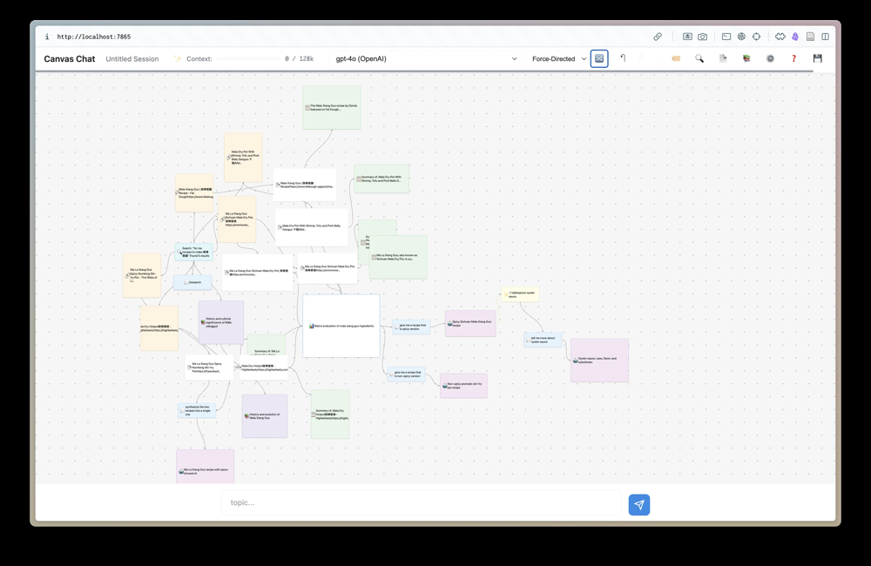
Canvas Chat’s interface: conversation branches visualized as colored nodes on a canvas[5].
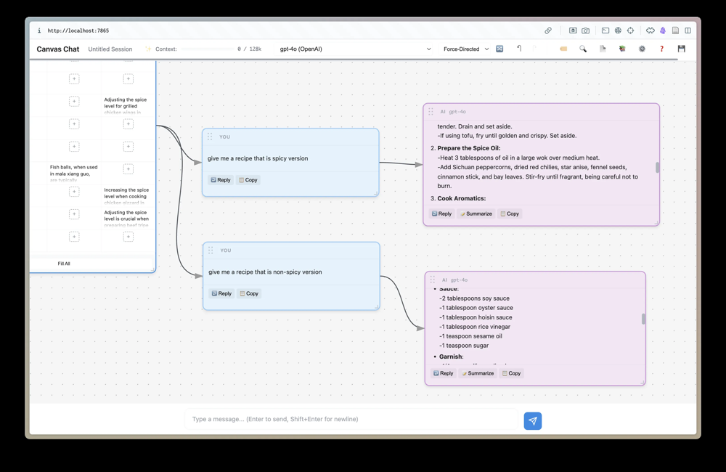
Example Canvas Chat scenario: asking for a spicy vs. non-spicy recipe forks into two parallel branches, each with its own conversation (blue “You” prompts → purple LLM responses)[5].
- ChatBranch (ReadyTensor) – An enterprise AI chat platform marketed around conversation trees[25]. Its literature emphasizes “visual conversation trees” and “parallel exploration paths”, claiming to solve context loss (reports that after ~10–15 turns AI forgets earlier context)[2]. ChatBranch highlights “context preservation”, multi-branching, and team collaboration (users create AI “personas” to reuse across branches)[26]. It uses tree interfaces and sub-branching for detailed analyses.
- Other Chatbots: As of 2025, most LLM-based chatbots (like Anthropic’s Claude or Google’s Gemini) do not have native branching UIs. Some developer tools (e.g. certain code assistants) offer limited “/fork” or “/resume” commands, but no built-in visual branching. Experts note “most LLM chat interfaces today offer only sequential dialogs instead of more flexible tree-like structures”[9]. This gap validates our approach.
Positioning: Our product will combine the best of these: a seamless, integrated UI (unlike ChatGPT’s separate tabs), multi-model support (like Canvas and Methodox), and explicit merge/synthesis tools (beyond what others offer). We also emphasize enterprise requirements (security, collaboration, APIs) to go beyond consumer tools.

Technical Feasibility & Architecture
- LLM Integration: Leverage major LLM APIs (OpenAI GPT-4+/5, Anthropic Claude, Google Gemini, etc.). Use a stateless backend to proxy requests (like Canvas Chat’s approach: LLM keys in user’s local storage, no server retention)[27]. The system should fetch available models dynamically and allow switching mid-conversation[13].
- Conversation Data Model: Represent chats as a Directed Acyclic Graph (DAG) of messages. Each node stores a message, with edges for parent→child relationships. DAGs are a natural fit: previous research models conversation context as a DAG to capture branching structure[28]. In practice, each message record would include pointers to its parent(s) (supporting multi-select merges). Use a database (e.g. a graph database or any store that can index by ID) to manage nodes and their relationships.
- Context Management: Each time the user sends a prompt on a branch, we gather the ancestor nodes of that branch (possibly union of multiple if merged) as context history. Canvas Chat “walks the DAG backward from selected node(s) … collecting all ancestors” to send to the LLM[16]. We will implement a similar algorithm. When merging branches, we can optionally send only new or unique content. To stay within model limits, we may need to summarize or drop older context. Industry research warns that models “can see” only a limited context; anything beyond that must be truncated or summarized[15].
- UI Framework: The frontend needs a dynamic, possibly drag-and-drop interface to visualize the graph. Technologies like WebGL (via libraries like PixiJS, Three.js, or Cytoscape) or optimized Canvas (e.g. D3+Canvas) are suitable. Studies show SVG/Canvas UIs degrade after ~10k elements, while WebGL scales better for many nodes[14]. Since we target ~100–500 nodes per session, we should test rendering performance early. We'll likely use a virtual viewport and load only visible parts of the graph (progressive loading).
- Backend & Performance: The backend should efficiently handle conversation state. Techniques:
- Checkpointing: Save conversation checkpoints at branch points to avoid re-sending full history.
- Selective Context: Send only the active branch’s ancestry (and any merged content) to the LLM, rather than the entire tree, to cut token usage. This echoes ContextBranch’s approach, which “reduced context size by 58.1% (31.0→13.0 messages)” in branched chats[18].
- Caching: Cache LLM responses so that if a branch is reopened or a prompt retried, we can reuse or compare results.
- Collaboration & Concurrency: In multi-user mode, handle edits with basic locking or CRDT techniques to prevent conflicts (e.g. if two users edit the same branch simultaneously). Version control semantics (like Git) can inspire conflict resolution (users manually resolve merge conflicts if two branches change the same parent).
- Security Compliance: Incorporate enterprise-grade encryption (in transit and at rest). Follow zero-trust principles (e.g. each API call is authenticated/authorized). Audit logs will record who branched/merged what and when. This meets requirements for “role-based access, logging” (RB-7).
Overall, the architecture combines a graph data layer, an LLM orchestration layer, and a dynamic UI. Existing prototypes (Canvas Chat, Methodox) prove feasibility of core ideas. Our innovation lies in hardening it for scale and integrating team features.

Implementation Roadmap (Months 1–18)
Based on technical scope and competitor timelines, we propose an iterative rollout:
- Phase 1 (Months 1–3): Design & Core Engine
- Define detailed UX/UI prototypes for the conversation tree view and branching tools (wireframes, user flows).
- Develop the backend graph data model (schema for storing messages and edges).
- Integrate a baseline LLM API (start with GPT-4) and implement basic chat flow.
- Implement core branching logic: “fork thread” action that clones current context to a new branch.
- Ensure context isolation: switching to a branch only sends that branch’s context.
- Phase 2 (Months 4–6): Alpha Release & Iteration
- Release an internal alpha or pilot to select users. Gather feedback on UI/UX (e.g. is the tree view intuitive?).
- Refine UI performance (optimize rendering, implement lazy loading of deep branches).
- Add branch merging: allow summarizing or manually copying branch content back. Use LLM to assist with “compare these two branches” merges.
- Enable exporting conversation trees (e.g. to JSON/Markdown) and initial integration with tools like Notion or Confluence.
- Monitor KPIs (branch usage, completion time) with pilot users to validate improvements.
- Phase 3 (Months 7–9): Beta & Collaboration
- Launch a public beta (possibly free tier access) to get broader feedback.
- Implement real-time collaborative features: multiple users can view/edit branches (with basic locking or suggestions).
- Integrate additional LLM providers (Claude, Gemini). Allow switching models on a branch or running the same prompt on two models for comparison.
- Collect usage metrics (KPIs) and iterate on pain points (e.g. simplify merge UX or improve context recall as needed).
- Phase 4 (Months 10–12): Version 1.0 & Scaling
- Release 1.0 with enterprise features: Single Sign-On (SSO), team management, advanced security (audit logs, encryption keys).
- Polish UI on all platforms (responsive design, mobile/tablet).
- Performance tuning for large organizations (load testing with hundreds of sessions).
- Launch marketing and onboarding for enterprise customers (demos, documentation).
- Year 2 (Growth & New Verticals)
- Q1: Integrate knowledge bases and enterprise data sources (RAG) so users can query internal docs within branches.
- Q2–Q4: Explore AI co-author features: auto-suggested follow-up questions, branch prompts, or summary insights. Possibly add “AI agent” assistants that recommend branching points.
- Continue adding provider integrations (self-hosted models) and advanced analytics (e.g. conversation heatmaps).
This roadmap prioritizes branch fundamentals first, followed by visualization, collaboration, and enterprise polish. It aligns with industry: for example, OpenAI began exploring branching in early 2025 and shipped it by late 2025[4], a ~9-month cycle.

Implementation Risks & Mitigations
- Complex UX/UI: Designing an intuitive branching interface is challenging[29]. Users may get overwhelmed by too many branches. Mitigation: Invest in user testing of prototypes; start with a simple view (e.g. collapsible branches) and add features iteratively. Provide tutorials and sane defaults (e.g. collapse inactive branches).
- Performance with Large Trees: Rendering hundreds of nodes can lag the browser[14]. Mitigation: Use high-performance rendering (WebGL/canvas). Implement dynamic loading of off-screen nodes and virtual scrolling.
- Context Overload: Without care, branches could accumulate too much chat history. Mitigation: Enforce context windows: only send relevant ancestor nodes to the LLM[15]. Use summarization (LLM-based) to condense old context.
- Data Security & Compliance: Storing proprietary conversations requires trust. Mitigation: Encrypt data, follow best practices (e.g. those outlined in LLM security guidelines). Use audit logs and allow enterprises to self-host or use private LLM instances.
- Merge Conflicts: Merging divergent branches might be confusing. Mitigation: As in version control, highlight differences and let the user resolve conflicts manually. Provide AI-generated merge suggestions (as a draft) but keep user in control.
- User Adoption: Users may resist changing from familiar linear chat. Mitigation: Clearly demonstrate the benefits (time saved, clarity). Provide use-case templates (e.g. “Brainstorm” mode). Monitor feedback and iterate UI ease-of-use.
- Vendor Lock-in (LLM changes): LLM APIs can change (pricing, rate limits). Mitigation: Support multiple providers; allow on-prem/self-hosted models; implement token usage monitoring.
Each risk is managed through design choices, testing, or gradual rollout. For example, acknowledging that UI complexity is hard[29], we plan iterative refinement with real users. Performance issues are addressed with proven techniques[14]. Security is non-negotiable and built in from day one (encryption, RBAC).

By rigorously defining requirements, learning from existing tools, and following a staged roadmap, this branching conversation platform will enable knowledge workers to “think visually with AI”, turning tangled dialogs into structured, context-rich trees[17][25]. Tracking our KPIs will ensure it delivers on the promise of faster, clearer decision-making.
Sources: We based this analysis on industry research and existing tools. For instance, the ContextBranch study demonstrates the benefits of branching[17], and projects like Canvas Chat and Methodox Threads provide concrete feature examples[5][30]. OpenAI’s own release notes confirm branching in ChatGPT[4]. All cited facts above are drawn from these connected sources.

[1] [3] [17] [18] [2512.13914] Context Branching for LLM Conversations: A Version Control Approach to Exploratory Programming
https://ar5iv.labs.arxiv.org/html/2512.13914
[2] [8] [25] [26] ChatBranch: The AI Conversation Platform That Changes How We Think
https://app.readytensor.ai/publications/chatbranch-the-ai-conversation-platform-that-changes-how-we-think-HFKsqg1ERUig
[4] ChatGPT — Release Notes | OpenAI Help Center
https://help.openai.com/en/articles/6825453-chatgpt-release-notes
[5] Canvas Chat: Building a Visual Interface for Nonlinear LLM Thinking
https://dspn.substack.com/p/canvas-chat-building-a-visual-interface
[6] [21] [22] [23] [24] [30] Introducing Methodox Threads: Tame the Chaos of Branching AI Conversations - DEV Community
https://dev.to/methodox/introducing-methodox-threads-tame-the-chaos-of-branching-ai-conversations-2fl5
[7] [9] [12] [29] Product Idea: Enhanced Chat Dialogue with Branching (Forks) and Research Mode - Feature requests - OpenAI Developer Community
https://community.openai.com/t/product-idea-enhanced-chat-dialogue-with-branching-forks-and-research-mode/1137856
[10] [11] [13] [16] [27] Canvas Chat: A Visual Interface for Thinking with LLMs - Eric J. Ma's Personal Site
https://ericmjl.github.io/blog/2025/12/31/canvas-chat-a-visual-interface-for-thinking-with-llms/
[14] mt.inf.tu-dresden.de
https://mt.inf.tu-dresden.de/cnt/uploads/Horak-2018-Graph-Performance.pdf
[15] LLM Context Window Limitations in 2026
https://atlan.com/know/llm-context-window-limitations/
[19] About branched conversations - Feature requests - OpenAI Developer Community
https://community.openai.com/t/about-branched-conversations/1081847
[20] GPTree - Branch, Compare & Merge From ChatGPT - Chrome Web Store
https://chromewebstore.google.com/detail/gptree-branch-compare-mer/nailcemhpkhjfbbpckjdckjggdgknfld
[28] Directed Acyclic Graph Network for Conversational Emotion Recognition
https://aclanthology.org/2021.acl-long.123.pdf

